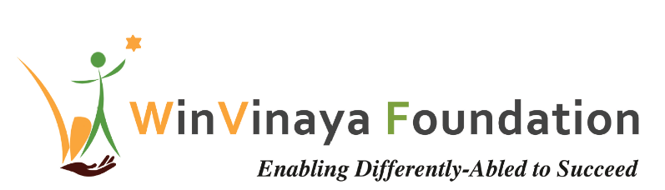

____________________________________________________

Employability Training Program

For persons with Disability in Bangalore, Karnataka

Proposal by

WinVinaya Foundation

To

SBI Foundation

Date of Proposal: 03rd Jan 2020

Project Contact: Sivasankar Jayagopal

Founder Chairman

WinVinaya Foundation

25/3 Brindavan 3rd Cross, Saraswathipuram

IIM Post

Bangalore 560076

Ph.: +91-96764-33359

Email: [Shiva.Jayagopal@WinVinayaFoundation.org](mailto:Shiva.Jayagopal@WinVinayaFoundation.org)

Table of Contents

1 Project Summary 3

1.1 Background 3

2 Introduction about WinVinaya Foundation 3

3 Our Understanding of the Project Requirements 3

3.1 Project Objectives 3

3.2 Focus of Training 3

4 WinVinaya Foundation’s Approach to meet the Requirements 4

5 WinVinaya’s Differentiating Factors 6

5.1 4 Step Guided Learning 6

5.2 Sign Language – eSL Platform 7

5.3 Interactive Realtime Dashboards 7

6 Implementation Plan 7

7 Volunteer Engagement 7

7.1 Technical Training/ Soft Skills Training 7

7.2 Mock Interviews 7

7.3 Improve WinVinaya Operations 8

8 Project Budget Information 8

9 Appendix – 1 – Sample Dashboard of WinVinaya Foundation (2018-19) 9

10 Appendix – 2 – Few Success Stories of WinVinaya’s candidates 10

11 Appendix – 3 – Team Building Games at WinVinaya Foundation 11

# Project Summary

## Background

SBI Foundation intends to sponsor employment training program, focused on BFSI domain (Banking, Financial Services and Insurance) for 100 persons with disability per year for 3 years which will enable them to join the industry workforce.

WinVinaya Foundation would like to propose this project to consider Transgender People and Ex-Service Persons as beneficiaries in addition to Persons with Disabilities. It will be great if we can consider two training programs – one focused on BFSI and another on IT Skills. This will help us provide more career opportunities to the beneficiaries.

# Introduction about WinVinaya Foundation

WinVinaya Foundation, a Charitable Trust was registered in Feb 2016 by Shiva Jayagopal who is an IT Veteran with 28+ years in IT and Seethalakshmi (Akila) who has 15+ years of experience working with Persons with Disabilities. Our primary aim is to empower Persons with Disabilities, economically disadvantaged and women to earn a decent income and lead a life with dignity by providing life skills and resources. We operate a center in Bangalore and a center in Tirupur. Based on our industry research, we are extending our courses to Ex-Service Persons and Transgender People so that they can earn a better income and lead a life with dignity.

# Our Understanding of the Project Requirements

## Project Objectives

* To train 100 beneficiaries per year for 3 years (total: 300 beneficiaries) on Banking, Financial Services & Insurance domain + IT Skills
* Beneficiaries will include Persons with Disabilities, Transgender people, Ex-Service Persons
* Provide interview opportunities for 80% of trained candidates
* To ensure 50% of the trained candidates are placed in companies and support for a minimum of 3 months

## Focus of Training

Based on our experience, we believe that a combination of –

1. Training in BFSI domain, IT +
2. Training in Soft Skills +
3. Basic English Communication
4. Mentoring by experts
5. Augmented with Digital Learning Platforms

* Will help the candidates learn very effectively and will help them get a job and progress in life.

# WinVinaya Foundation’s Approach to meet the Requirements

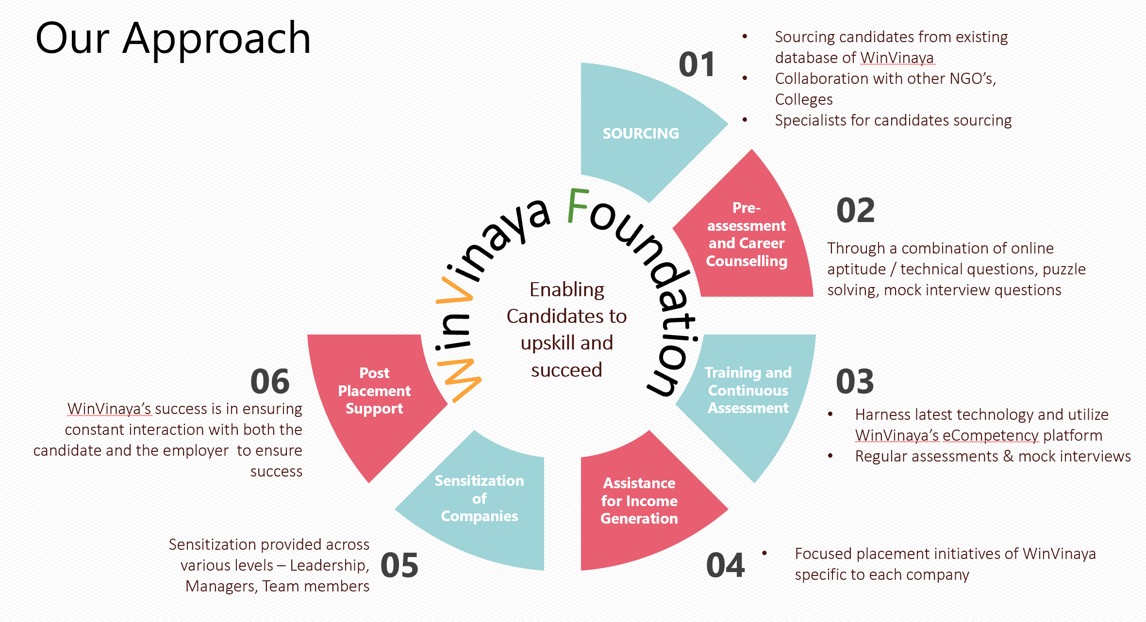

**Sourcing of Candidates for training**

* WinVinaya has a database of candidates who can be trained
* WinVinaya collaborates with colleges, NGOs, Specialists, Social Media, Alumni to source the candidates
* The candidates will be a combination of freshers looking for a job or experienced persons who are looking for better career growth

**Screening & Career Counselling**

* WinVinaya will do a pre-assessment of the candidates through a combination of online aptitude/ technical questions, puzzle solving, mock interview questions to assess their knowledge levels, interests, readiness for jobs and provide career guidance.
* Pre-assessment results help us to choose the appropriate training methodology, duration and make it more effective as per the skills of the candidates.

**Training & Skilling**

* WinVinaya has trained 250+ candidates across various streams – IT/ ITES, Soft skills, HR, Finance, Tally.
* WinVinaya will be using class room training, distant learning using digital learning platforms or a combination of both to provide the training.

**Training Assessments**

* Harness latest technologies - We built WinVinaya’s e-Competency Assessment platform to help the candidates prepare better through multiple practice tests.
* Through WinVinaya’s e-Competency Assessment platform, we regularly check the skill levels of the candidates which will help us make appropriate course correction in the training.
* We conduct 2 Mock interviews - One in the middle of the training and another at the end of the training. This helps in assessing the technical and soft skills of the candidates in an interview setting, which greatly helps them in clearing real-time interviews.

**Placement / Recruitment**

* Out of 250+ trained candidates in the last few years, WinVinaya has a track record of placing more than 70% of the candidates.
* WinVinaya’s focused company specific placement drives help in effectively mapping candidates to the recruitment needs of the organizations and facilitate the minimum hit rate of 50% placement

**Sensitization of Companies**

WinVinaya conducts Sensitization Workshop through which we sensitize leaders, managers, team members, Support Teams on the best practices in integrating PWD’s, Transgender people, Ex-Service people in the workplace. This has helped companies succeed not only in recruiting the candidates but also be successful in embracing them.

**Post Placement Support**

* WinVinaya believes that our part does not end just with placing the candidates. Through our experience we have realized that both Companies and the Candidates need some support, mentoring to ensure that the inclusive journey is successful.
* We provide post placement support to the company and the candidates for minimum 3 months.

# WinVinaya’s Differentiating Factors

WinVinaya Foundation was started and built by IT Veterans. We focus a lot on using effective products, tools, methodologies to make our training very effective. With an experience of training around 250 candidates with about 70% placement, WinVinaya’s successful methodology of harnessing technology is ideal to scale. Our differentiating factor is not on what we train, but on How we train.

**Some of the innovative and effective Products and Tools we intend to use for this program are:**

## 4 Step Guided Learning

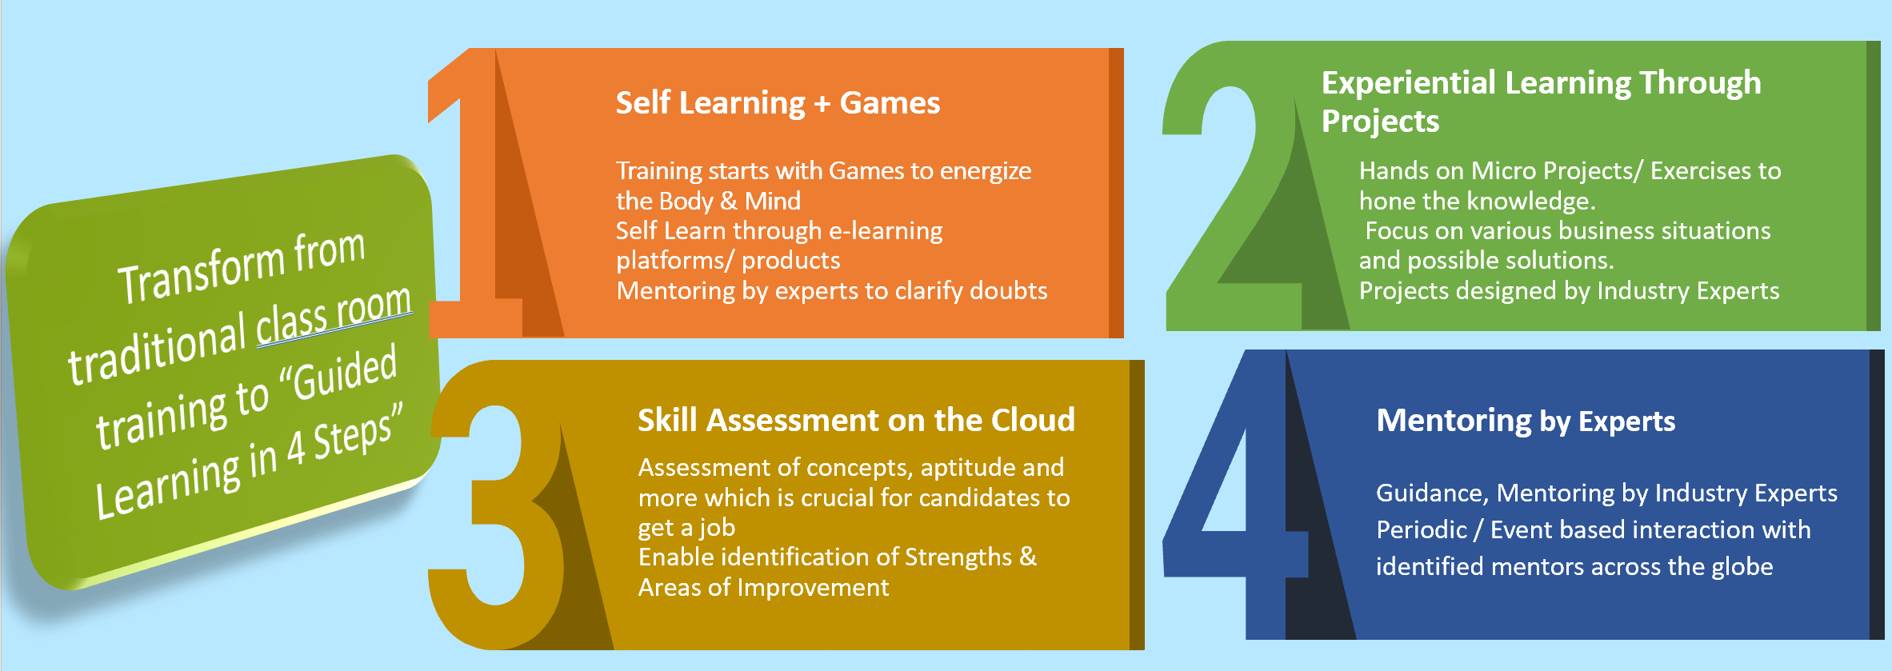

As part of the training, we will implement WinVinaya’s Guided Learning in 4 Steps:

* Self-Learning + Games:
  + Learn English through e-Learning platforms, products – For e.g. Learn English through “Flow of English” product.
  + Learn soft skill training by playing games. Please see a sample video on Team bonding game, here - <https://www.youtube.com/watch?v=XHyp39KYA4U>
* Experiential Learning through Projects
  + With Industry Experts in the foundation, the focus is on creating Projects / Exercises with real time scenarios which will improve the “Application of Knowledge” skills
* Skill Assessment on the Cloud
  + WinVinaya’s eCompetency Platform will be used for evaluating the candidates
  + More than 750 questions on IT, Aptitude, English & GK are already loaded on the platform
  + This platform will be used for Regular Assessments, Pre Training and Post Training Assessments of candidates to understand the Strengths and Areas of Improvement
  + This platform will also be used for mock online test before the Placement
* Mentoring by experts
  + Expert volunteers provide the requisite guidance to the candidates to succeed
  + The guidance would be periodic, and event driven. Their inputs on what they are doing well and what they need to improve along with tips to improve has made a very big difference for the candidates to succeed.

## Sign Language – eSL Platform

Many Hearing & Speech Impaired candidates communicate through Sign Language. However, the companies that are willing to recruit them don’t have many employees who know Sign Language. WinVinaya has created “WinVinaya eSL”. This is a self-learning course where anyone can learn the foundations of Sign Language through videos structured through a lesson plan. Within a few days, the Sign Language course can be completed.

We strongly believe that platforms like these will enable the community to learn Sign Language which will help make this world become more inclusive.

## Interactive Realtime Dashboards

WinVinaya Foundation believes not just in collating the information and reporting on periodic basis, but also in analyzing the information for further improvements. To this end, we built dashboards for Monitoring Training, Placement of candidates. Please see Appendix 1 for the sample dashboard.

# Implementation Plan

|  |  |
| --- | --- |
| Training Location | WinVinaya’s Existing Center in Bangalore |
| No. of Beneficiaries | 100/ year * 3 Years = 300 |
| Duration of the Course | 100 Hours to 200 Hours – approximately 4 weeks to 8 weeks per student  Batch Duration may vary slightly from plan depending on the batch needs and the skill of the candidates |
| Overall Project Duration | 36 months |

# Volunteer Engagement

Employees of SBI Foundation are most welcome to volunteer and support our initiatives and enable Persons with Disabilities to lead a life with dignity. There are multiple ways in which volunteers can make a positive impact-.

## Technical Training/ Soft Skills Training

Provide training for one or more days a month on improving technical skills, communication, increasing confidence, interviewing skills, teamwork and more through classroom mode or through fun filled games.

## Mock Interviews

Volunteers can be part of mock interviews which helps the candidates to shed their fear and anxiety in facing interviews. Provide authentic feedback on what the candidates did well and where they should improve.

## Improve WinVinaya Operations

Volunteers can help WinVinaya to improve the entire process (from sourcing candidates to placing the candidates to getting funds from sponsors) or selected few key process areas, to significantly increase the social impact.

# Project Budget Information

It costs us approximately Rs 30,800/- per candidate to complete the training and provide placement and post placement assistance.

|  |  |  |  |  |
| --- | --- | --- | --- | --- |
| **Cost head** | **Description** | **Units** | **Unit cost** | **Total** |
| Cost of facilities | Rentals for premise | 36 | ₹ 40,000 | ₹14,40,000 |
| Mobilization of candidates | Cost of outreach (travel; meetings & mobilization sessions; social media; internet; counselling, advertisement/flyers; pre-assessment, enrolments ) | 300 | ₹ 1,500 | ₹4,50,000 |
| Training of candidates | Training cost including cost of accessible study materials, sign language interpreter, accommodation for some candidates, systems and software, Broadband/ Network, Computer Maintenance, Events like Mock Interview, Certificate Distribution, and retraining wherever needed | 300 | ₹ 22,000 | ₹66,00,000 |
| Assessments | Online and Offline Assessments | 300 | ₹ 500 | ₹1,50,000 |
| Job placement | Including branding, food and travel  costs for candidates, sign language interpreter costs | 300 | ₹ 2,000 | ₹6,00,000 |
| **Total** | **Rupees Ninety Two Lakhs and Forty Thousand only** |  |  | ₹**92,40,000** |

# Appendix – 1 – Sample Dashboard of WinVinaya Foundation (2018-19)

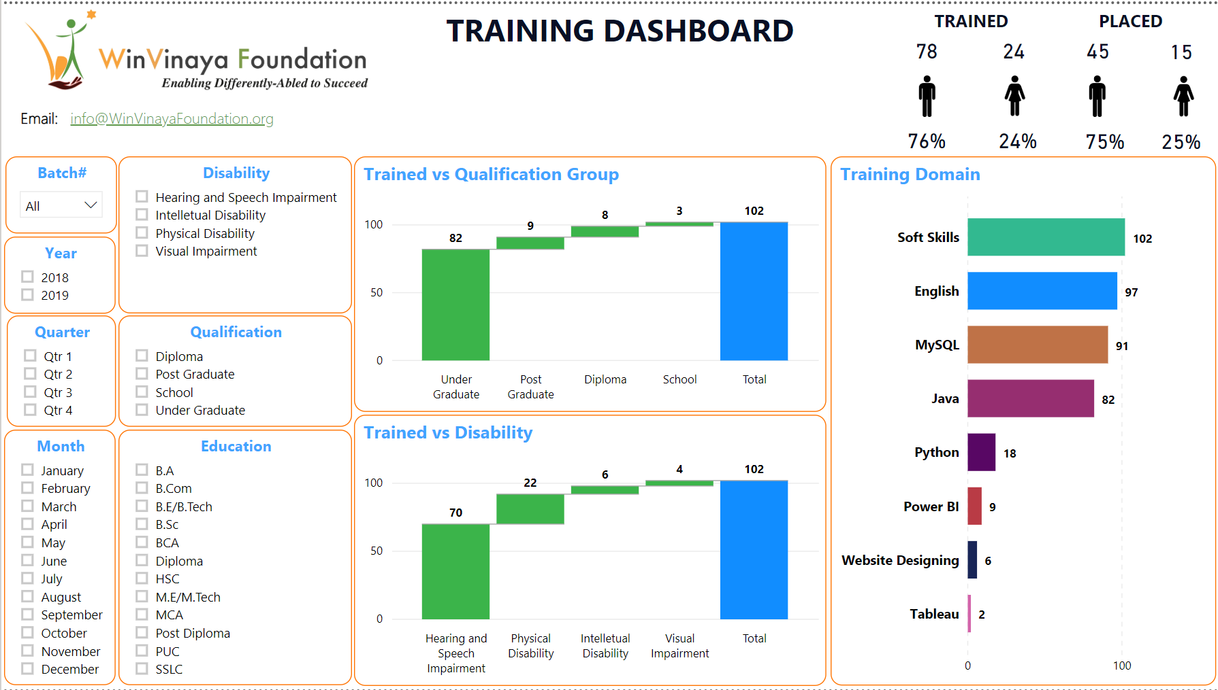

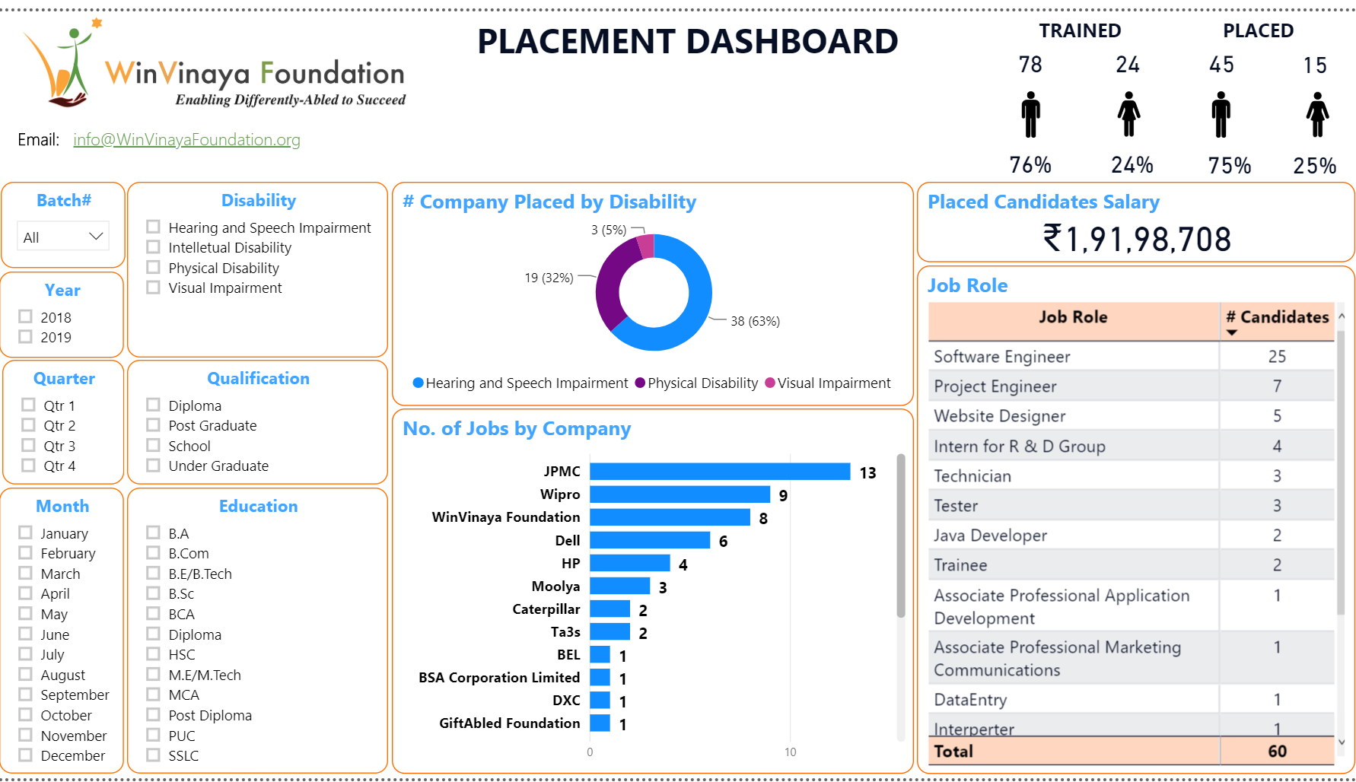

# Appendix – 2 – Few Success Stories of WinVinaya’s candidates

1. **Success Story of Anoop**

Anoop is a Hearing & Speech Impaired person from Kerala. He uses Sign Language to communicate. Even though there are 400+ educational institutions for the deaf in India, almost 95% of them don’t have qualified sign language instructors. In other words, we are NOT educating the deaf in an effective way.

Anoop experienced this the hard way. But then, Anoop is a strong willed, smart, hard working person. Watch this video to see how Anoop transformed his life - [Success Story of Anoop](https://www.youtube.com/watch?v=b-rXnVXsSo4)

1. **Success Story of Lohith**

Lohith is a Person with Low Vision from Karnataka. He wanted to do Engineering, which includes design drawings, practicals, labs… Some raised questions if that is the right course for him. He took it as a challenge and completed Mechanical Engineering.

He then decided to explore the IT sector. He got himself trained in software development and landed a job in a top MNC. When there is a will, there is a way. Watch his story - [Success Story of Lohith](https://www.youtube.com/watch?v=uhxWfwuIVlE&t=148s)

1. **Success Story of Jayashree**

Jayashree is a Person with Locomotor Disability from Karnataka. When she was born, her parents were very worried about the future of their girl child with disability. It was NOT easy to get school admission.

Fast Forward. Jayashree completed MCA. She fine tuned her skills and is now working in a top MNC & is the primary bread winner of her family - A Person with Disability supporting people without disabilities. Watch her story of GRIT – [Success Story of Jayashree](https://www.youtube.com/watch?v=baxYr3XPDPM&t=16s)

# Appendix – 3 – Team Building Games at WinVinaya Foundation

Games are an integral part of learning at WinVinaya Foundation. We harness the power of games to improve self confidence, enhance logical thinking & reasoning, team building skills, leadership building skills.

**Given below are the videos of some of the games played at WinVinaya Foundation.**

**Leadership Building Games -** [**https://www.youtube.com/watch?v=pk7A2fg7Y5A**](https://www.youtube.com/watch?v=pk7A2fg7Y5A) **Team Co-ordination Games -** [**https://www.youtube.com/watch?v=XHyp39KYA4U**](https://www.youtube.com/watch?v=XHyp39KYA4U) **Team Building Games -** [**https://www.youtube.com/watch?v=F_iDYr55HFI**](https://www.youtube.com/watch?v=F_iDYr55HFI)

